RPM Arrays Plots from Dyno Data

Zainab Hussein

3-23-2017

# Background

# Hypothesis

# Method and Result

**Interpolation: Columns – 224, Rows - 22**

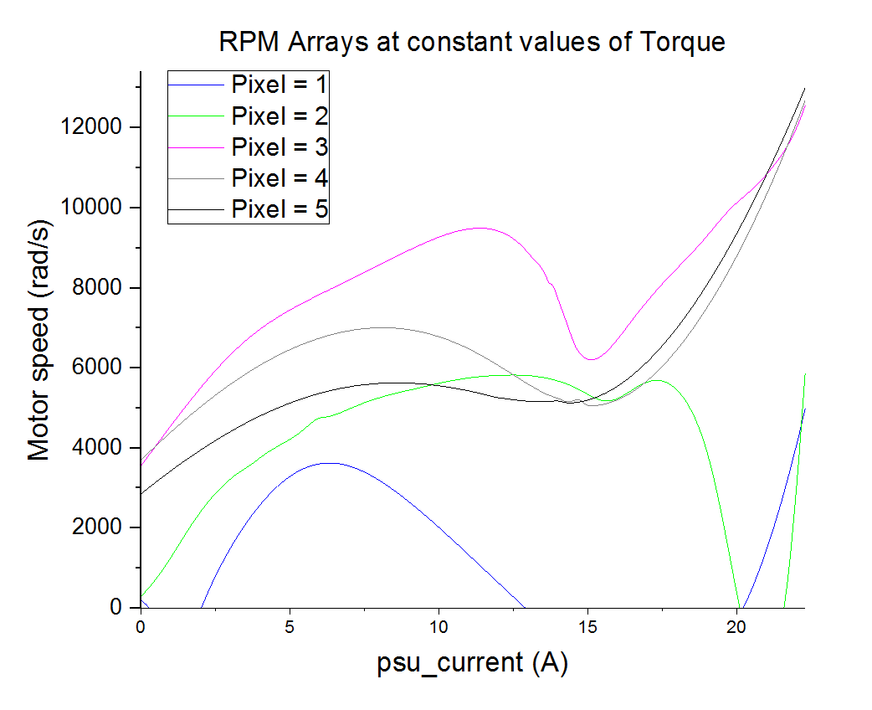

Figure 1 RPM Arrays at constant Torque

## Table 1

|  |  |  |
| --- | --- | --- |
| RPM at Constant Torque values | | |
|  | Actual Torque (Nm) | Approximate Torque (Nm) |
| Pixel 1 | 0.01191 | 0 |
| Pixel 2 | 5.014 | 5 |
| Pixel 3 | 9.976 | 10 |
| Pixel 4 | 14.98 | 15 |
| Pixel 5 | 19 | 20 |

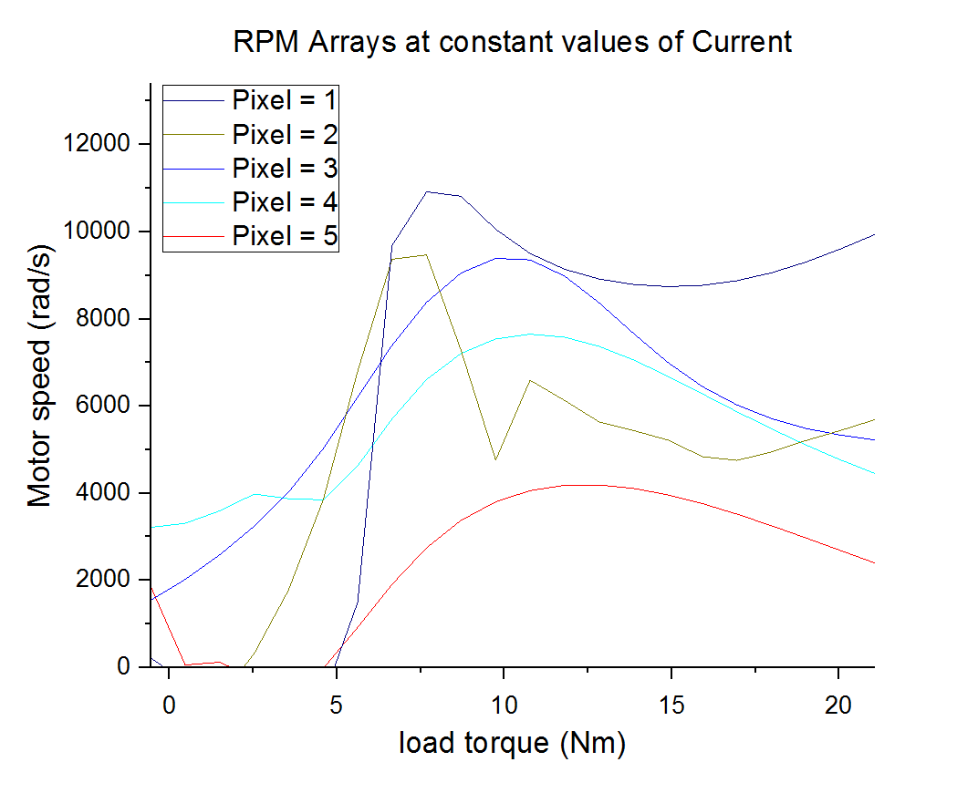

Figure 2 RPM arrays at constant Current

## Table 2

|  |  |  |
| --- | --- | --- |
| RPM at Constant Current values | | |
|  | Actual Current (A) | Approximate Current (A) |
| Pixel 1 | 20 | 20 |
| Pixel 2 | 15.01 | 15 |
| Pixel 3 | 9.982 | 10 |
| Pixel 4 | 5.031 | 5 |
| Pixel 5 | 0.2 | 0 |

# References:

Plotting 3D surfaces in Origin: <http://wiki.originlab.com/~originla/howto/index.php?title=Tutorial:3D_Plotting>

<http://www.originlab.com/index.aspx?go=Products/Origin/Graphing>